Conditions/ifelse statements:

If then statement
If this happens =do this
otherwise =do that

STEP 1: vi file_name
Step 2: Insert the data in file_name
While inserting data you need follow pattern
- Starting line with #!/bin/bash
- Count=100
- If [ $count -eq 100 ] (if statements)
- Then
- Echo count is 100
- Else ( Else statement)
- Echo count is not 100
- Fi ( fi marks as the end of if statements )
- Save the file using :wq!
Step 3: cat file_name to see the entered data
Step 4: give permissions using chmod 755 file_name
Step 5 : execute using ./file_name

Script 1: count is 100 or not
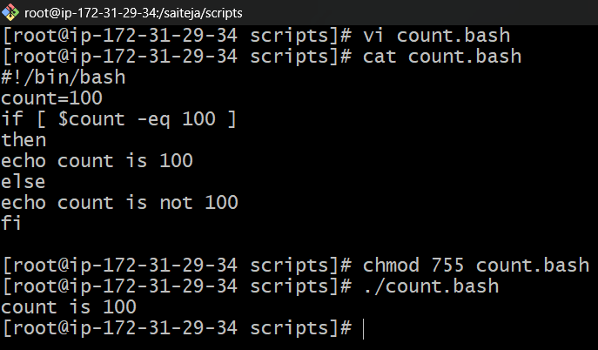
Script 2: check if file is exist or not
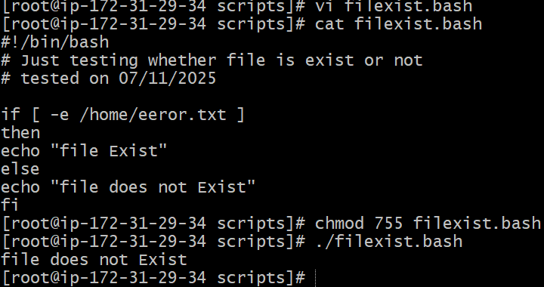
If file exist
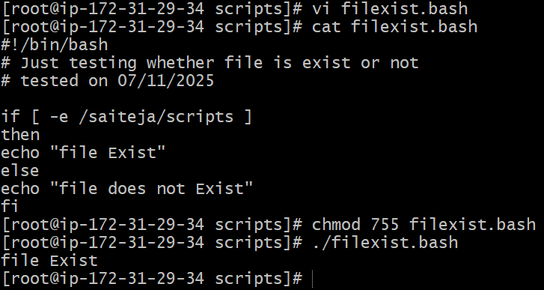

Script 3: case statements (multiple choice)
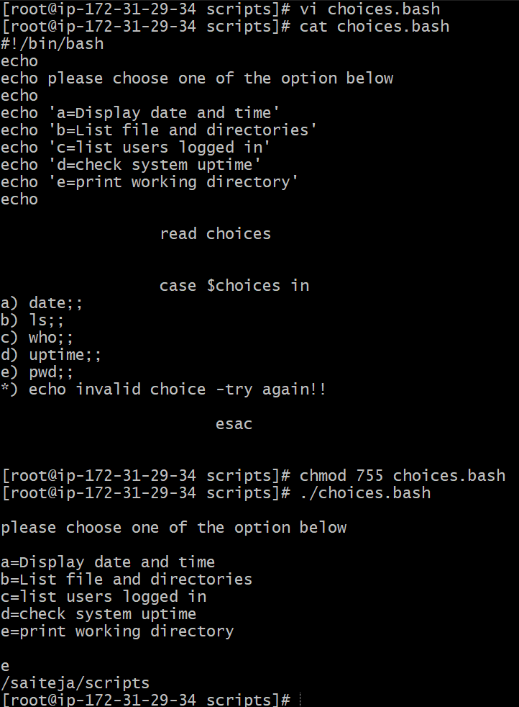

Script 3: LOOP SCRIPTS
For loop keeps running until specified number of variable.
e.g: variable = 10 then script run for 10 times.

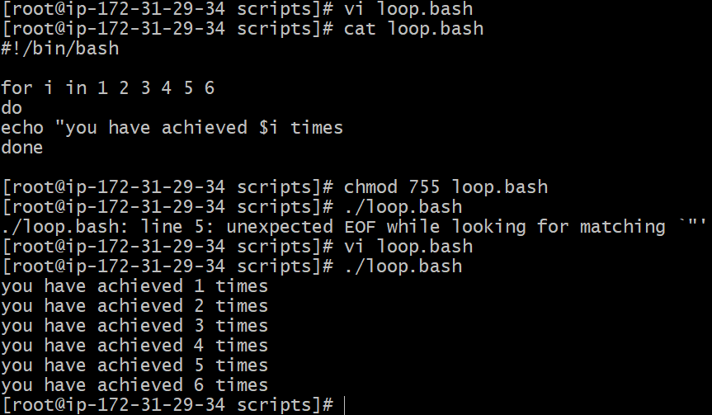
For infinite loop
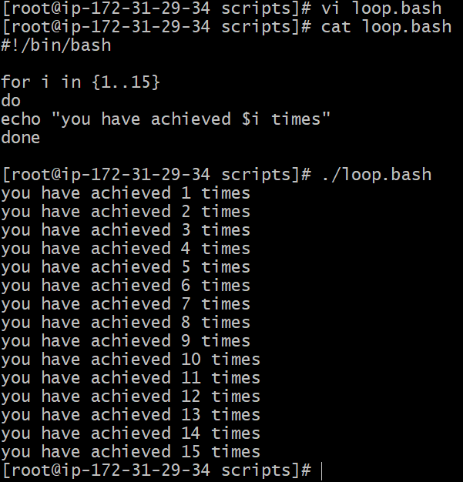
Script 4: Do While loop Statements
This will continuously executed a block of statements while a particular condition is true.
E.g Run a Script until 2pm

